Stacks and Queues

Exercise 1
Use the stack visualization program found on Moodle (stackVisual.zip) to re-familiarize yourself with the operation of a stack. Add elements to the stack using push and remove using pop. Notice the position pointed to by top
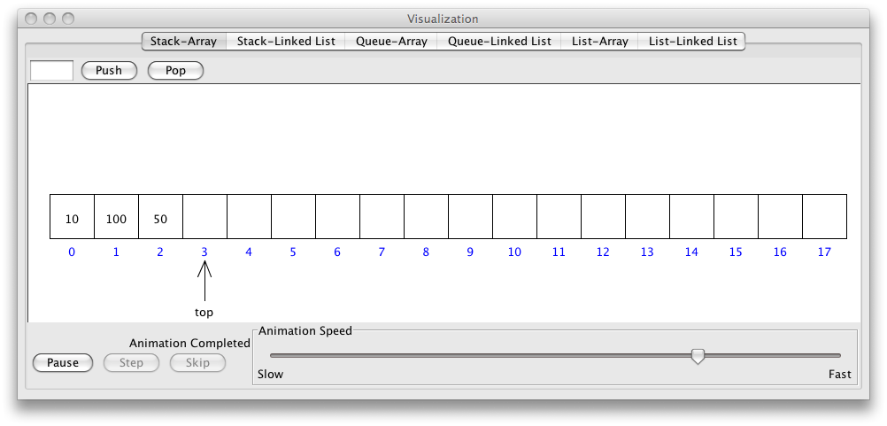

Exercise 2
The following code provides the outline of a simple stack class and a command line test program.
class Program
{
static void Main(string[] args)
{
IntStack mystack = new IntStack();

mystack.Push(10);
System.Console.WriteLine(mystack.Pop());

mystack.Push(20);
mystack.Push(30);
mystack.Push(40);

System.Console.WriteLine(mystack.Pop());
System.Console.WriteLine(mystack.Pop());
System.Console.WriteLine(mystack.Pop());

System.Console.ReadKey();
}
}

You will need to add a new class to your project in a file called IntStack.cs

class IntStack
{
private const int maxsize = 10;
private int top = 0;
private int[] array = new int[maxsize];

public void Push(int value)
{
// insert code here
}

public int Pop()
{

return array[--top];
}

public int Peek()
{
// insert code here
}

public bool IsEmpty()
{
return // insert code here
}

public bool IsFull()
{
return top == maxsize;
}

public string Print()
{
StringBuilder output = new StringBuilder();
for (int i = top - 1; i >= 0; i--)
output.Append(array[i] + Environment.NewLine);
return output.ToString();
}

}
Finish off the code for the Push, Peek and IsEmpty functions
Use the debugger variables window to examine the values in the array.
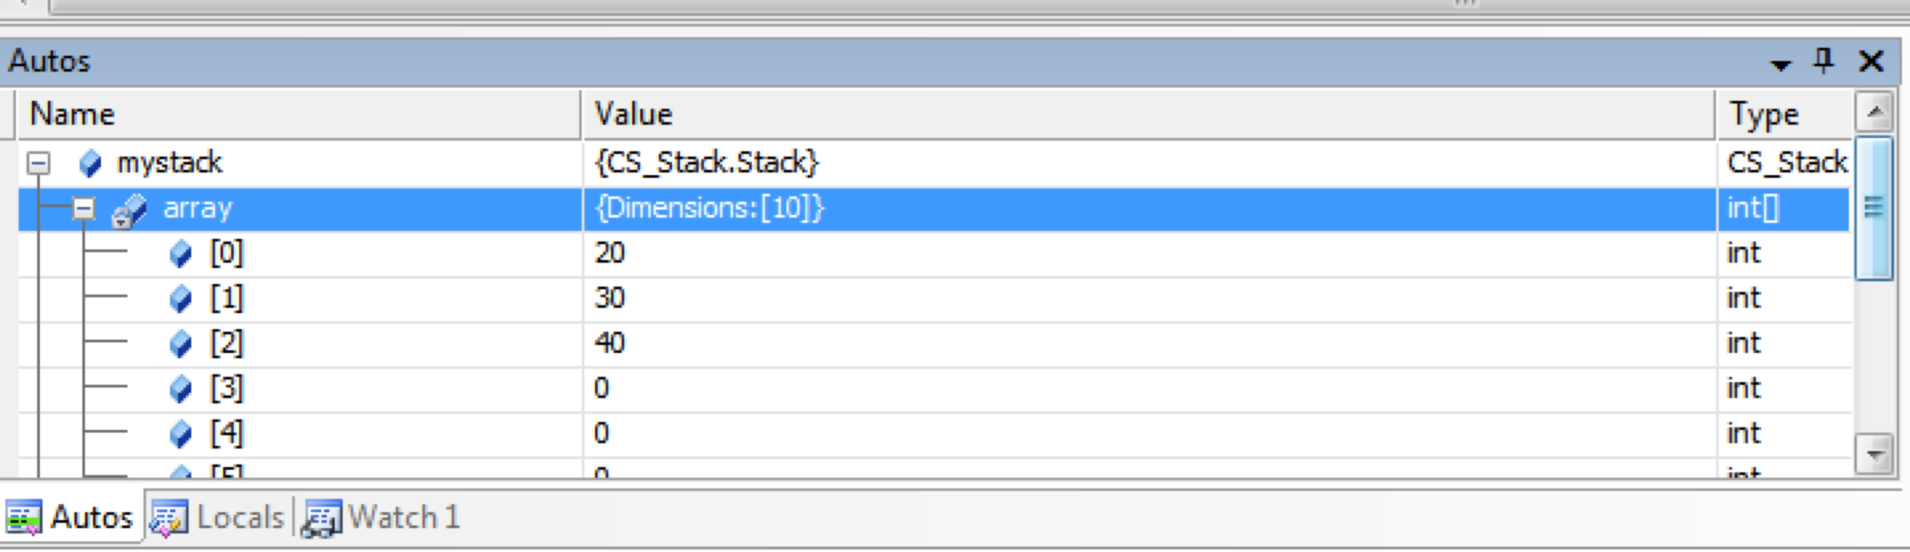

Exercise 3
In the test program (main) write a test program that :-
Uses a while loop to fill the stack with Random numbers.
Uses a separate while loop to pop each value and print it to the screen.

Random randgen = new Random();

randgen.Next(100) // will produce a random number between 0-100

Exercise 4
Again use the visualization program to familiarize yourself with the operation of a Queue selecting the Queue-Array tab.
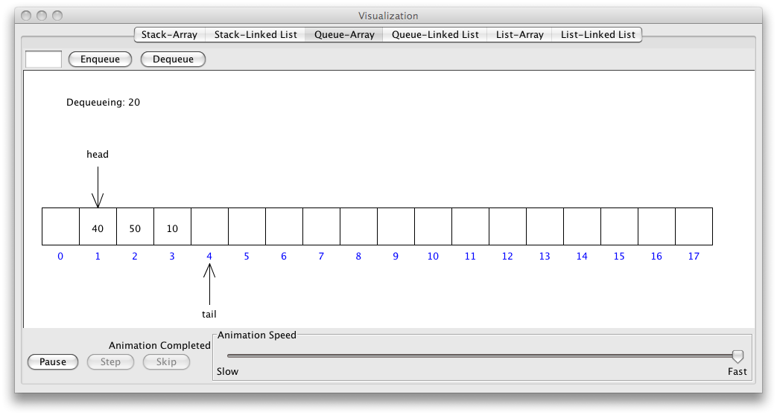

Exercise 5
In a new Project using the outline class below create a Queue class in file called IntQueue.cs and a main function to test your Queue.
class IntQueue
{
private readonly int maxsize = 10;
private int[] store;
private int head = 0;
private int tail = 0;
private int numItems;

public IntQueue()
{
store = new int[maxsize];
}

public IntQueue(int size)
{
maxsize = size;
store = new int[maxsize];
}

public void Enqueue(int value)
{
// insert code
}

public int Dequeue()
{
// insert code
}

public int Peek()
{
// insert code
}

public bool IsEmpty()
{
return //insert code
}

public bool IsFull()
{
return // insert code
}

} //class

Exercise 6
Create a new public function that returns the number of items in the Queue.

Exercise 7
Create a new public function within your Queue class that returns a string containing the contents of the Queue.

Exercise 8a (Portfolio Exercise)
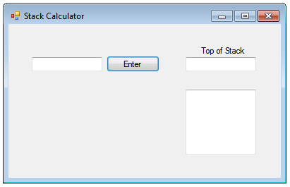
Download the RPN calculator that contains the skeleton code to produce the program shown above. You will need to replace the empty Stack class with your implementation.

Exercise b (Portfolio cont.)
Extend the program to implement the multiply ( * ) and division ( / ) operations as well.

Exercise 8c(Portfolio cont.)
In an RPN calculator an exchange function that exchanges the top two elements of the stack is useful. Extend the stack class to include the exchange function and extend the calculator so that when the user enter <> the top two elements are exchanged.
RPN is a form of postfix notation that is simpler to implement on computers than the regular infix notation we generally use. RPN has the advantage that Parenthesis are not required. HP sold many RPN calculators that were extremely popular in the 70’s. Even now HP sell a iPhone app which replicates the look of one of these early calculators for nearly 20GBP.
http://h41111.www4.hp.com/calculators/uk/en/articles/rpn.html
http://www.hpmuseum.org/rpnvers.htm

